Unofficial Translation

TECHNICAL GUIDELINES OF
THE USAGE OF GUEST BANK FACILITY
FOR PARTICIPANTS OF BI-RTGS AND BI-SSSS SYSTEM

This technical guideline of the usage of Guest Bank Facility aims for Participants of BI-RTGS System and Participants of BI-RTGS System who are also Participants of BI-SSSS System.
This technical guideline of the usage of Guest Bank Facility is differentiated into 3 conditions, namely:
- Usage of Guest Bank Facility early on the day
Participants have not performed transaction operation on RT and/or ST application
- Usage of Guest Bank Facility on midday (RT/ST Server is not crashed)
Participants have performed transaction operation on RT and/or ST application and Participants can still perform back-up Adhoc
- Usage of Guest Bank Facility on midday (RT/ST Server crashed)
Participants have performed transaction operation on RT and/or ST server but on midday RT/ST Server crashed that it can no longer be used.
- Procedures of the Usage of Guest Bank Facility early on the day
- Preparation of Participants (performed at the Participants’ office):
- Carry the result of RTGS end-of-day data back-up (T-1) in two storing media such as CD or flash disk.
RTGS end-of-day data back-up is done from RT Client menu Batch → Backup Daily Files.
The name of back-up file is for example: ddmmyy_backup (141207_backup)
- Carry the result of SSSS end-of-day data back-up (T-1) in two storing media such as CD or flash disk.
SSSS end-of-day data back-up is done from ST Client menu Batch → Backup Daily Files.
The name of back-up file is for example: ddmmyy_backup (ST_141207_BEIIIDJA)
- Carry transaction data that will be kept in financial entry or RTGS transaction data from bank internal system (text file) that will be up-loaded to RTGS application
- Carry transaction data that will be kept in financial entry or SSSS transaction data from bank internal system (text file) that will be up-loaded to SSSS application

- Guest Bank Activities (performed in Bank Indonesia) :
  - Bank Official will Restore RTGS Data from RT Super application
The procedures of RTGS data Restore:
  - Sign-on from RT Super application with user rtadm1 or rtadm2 and password default to restore RTGS
  - From the menu Utility choose Restore Tables. Restore Tables will be displayed.

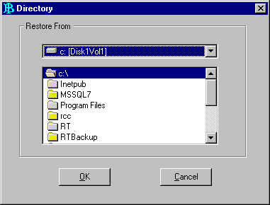

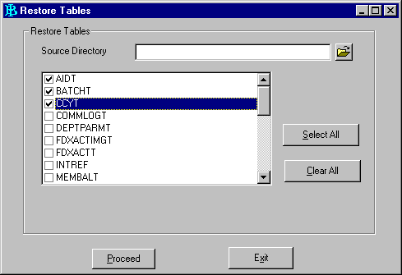
Image 1
  - Click to choose back-up file directory. Directory will be displayed.

Image 2

  - Choose Drive name from the list of driver list box and choose Folder from the list on folder list box to show the location of back-up file.
  - Choose tables to be restored:
Click Select All to choose all tables to be restored, except for these following tables:
- DEPTPARMT
- PRTDEV
- SYSPARMT
- WSPARMT
because to restore the tables, a database re-setting needs to be performed.
  - Click Proceed to start restore process.
  - After restore process is completed, this following message will be displayed:
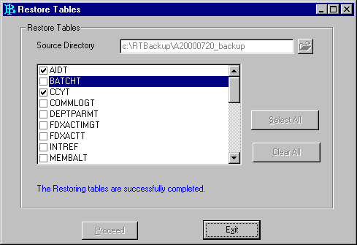
‘The Restoring Tables are successfully completed'.
Image 3
  - After restore is completed, click Exit to close this utility and then sign off from RT Super application.
  - Bank official will Restore SSSS Data from ST Super Application
Procedures of SSSS data Restore:
- Sign-on from ST Super application with user stadm1 or stadm2 and password default to restore SSSS.
- From the menu Utility choose Restore Tables. Restore Tables will be displayed.

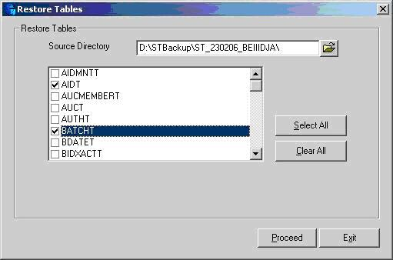
Image 4

- Click to choose back-up file directory. Directory will be displayed.

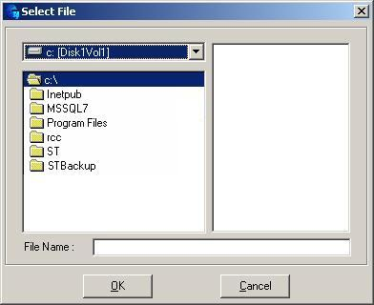
Image 5

- Choose Drive name from the list on driver list box and choose Folder from the list on folder list box to show the location of Back-up File.
- Choose tables to be restored:
Click Select All to choose all tables to be restored, except for these following tables:
- DEPTPARMT
- UPLISSUERT
- PRTDEV
- SYSPARMT
- WSPARMT
because a database re-setting needs to be performed to restore the tables.
- Click Proceed to start restore process.
- After the restore is completed, a message will be displayed:
‘The Restoring Tables are successfully completed'.
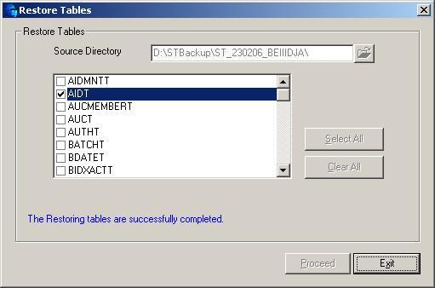
Image 6

- After restore is completed, click Exit to close this utility and then sign-off from ST Super application.
  - Bank Official will perform Batch Processing
The procedures:
    - Activate RT Server Application.
    - Activate ST Server Application
    - From RT Client application choose Batch menu and then perform Reset system Files process
    - From ST Client application choose Batch menu and then perform Reset system Files process
  - Bank Official will activate “Guest Bank” facility, as shown in the following image:
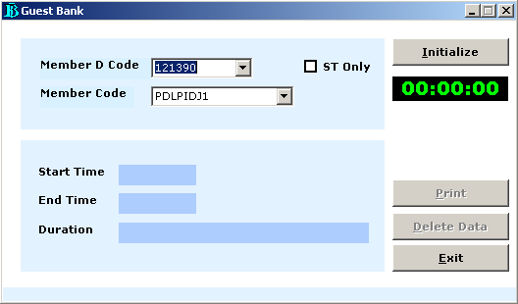
Image 7

Click Initialize to initialize Guest Bank Participant

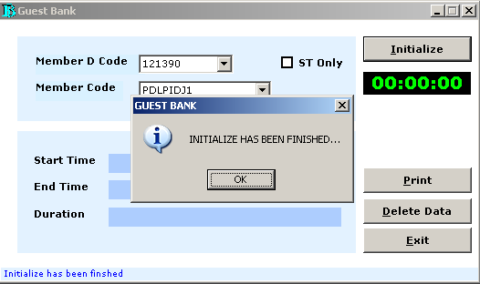
Image 8

  - Bank Official will perform RT and ST operational activity:
- Activate RT Server
- Activate ST Server
- Perform System start-up and Department start-up from RT Client
- Perform System start-up and Department start-up from ST Client
- Log-on to RCC from RT Client
- Input transaction data or up-load RTGS transaction data from the bank, from RT Client
- Input transaction data or up-load SSSS transaction data from the bank, from ST Client
- When it is done, Log-off from RCC from RT Client
- Recovery Activity after the usage of Guest Bank Facility (performed in Bank Indonesia) :
- If Guest Bank activity is performed until RCC Cut-off, perform these following procedures :
- Participants perform System shut-down without BATCH activity from RT Client Application
The procedures:
- Sign-on from RT Client application, with manager-level user
- From the menu System - System shut-down, choose End of day shutdown.
- Participants perform System shut-down without BATCH activity from ST Client Application
The procedures:
- Sign-on from ST Client Application, with manager-level user
- From System - System shut-down menu, choose End of day shutdown.
- Then maximize Guest Bank active application
- From Guest Bank application, click Print to print the duration of Guest Bank usage and the report will be printed as shown in the following image:

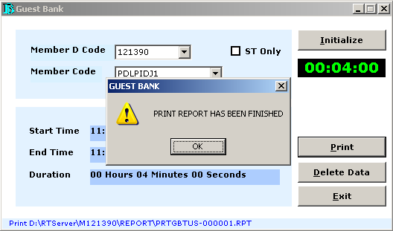
Image 9

- Then participants can perform BATCH activity from RT Client application.
The procedures:
- From RT Client main menu choose Batch → Print End of day Reports.
- From the main menu choose Batch → Backup Daily Files.
- Choose Directory.
- Choose Drive and Folder, then click <OK>.
- Click <Proceed>.
- From the main menu choose Batch → Reset system Files.
- Enter password.
- Click <Proceed>.

- Then participants can perform BATCH activity from ST Client application.
The procedures:
- From ST Client main menu choose Batch → Print End of day Reports.
- Choose the reports that will be printed:
  - Incoming Transaction Journal Batch Report
  - Outgoing Transaction Journal Batch Report
  - Due Date Reminder for SSSS Transaction Report
  - Daily Total Report
- From the main menu choose Batch → Backup Daily Files.
- Choose Directory.
- Choose Drive and Folder, and then click <OK>.
- Click <Proceed>.
- From the main menu choose Batch → Reset system Files.
- Enter password.
- Click <Proceed>.
- After Participants perform BATCH process, from “Guest Bank” application click Delete data to delete all performed RTGS and SSSS data transaction.
The procedures:
- From the main menu click Delete data and a message will be displayed as shown in the following image:
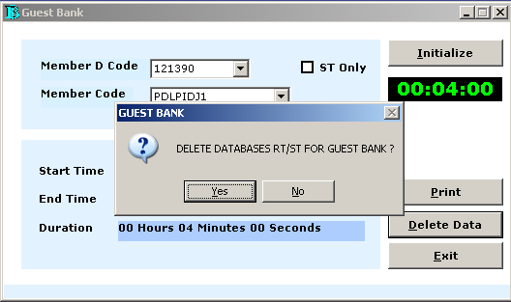
Image 10

- Click Yes to delete database
- When Delete database process is completed a message will be displayed as shown in the following:

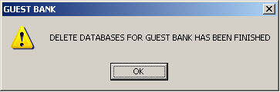
Image 11

- Click OK, then Exit from Guest Bank application
  - If Guest Bank activity is not performed until RCC Cut-off, then perform these following procedures:
- Participants perform System shut-down activity without BATCH activity from RT Client application
The procedures:
- Sign-on from RT Client application, with level-manager user
- From the menu System choose System shut-down, and then choose Mid Day Shut-down.
- Participants perform System shut-down activity without BATCH activity from ST Client Application
The procedures:
- Sign-on from ST Client application, with manager-level user
- From the menu System choose System shut-down, and then choose MidDay Shut-down.
- And then maximize active Guest Bank application
- From Guest Bank application, click Print to print the duration of Guest Bank usage and a report will be printed, as shown in the following image:

Image 12

- And then Participants can perform Adhoc Back-up from RT Super Application.
The procedures:
  - From RT Super main menu choose Utility → Adhoc Backup.
  - Choose Directory.
  - Choose Drive and Folder, and then click <OK>.
  - Click <Proceed>.
- And then participants can perform BATCH activity from ST Client application.
The procedures:
- From ST Super main menu choose Utility → Adhoc Backup.
- Choose Directory.
- Choose Drive and Folder, and then click <OK>.
- Click <Proceed>.
- When participants complete the BATCH process, click Delete data from “Guest Bank” to delete all RTGS and SSSS transaction data.
The procedures:
- From main menu click Delete data and a message will be displayed as shown in the following image:

Image 13

- Click Yes to delete database
- When Delete database process is completed, a message will be displayed as shown in following image:
Image 14

- Click Ok, and then Exit from Guest Bank application
- Next, the Bank performs Restore Data on the Server in the location of each bank.
The procedures:
  - RTGS Restore Data is performed from the menu RT Super – Utility – Restore Tables.
  - SSSS Restore Data is performed from the menu ST Super – Utility – Restore Tables.
  - Activate RT Server
  - Activate ST Server
  - Perform System start-up, Department start-up from RT Client
  - Perform System start-up, Department start-up from ST Client
  - Log-on to RCC from RT Client
  - Perform RTGS and SSSS operational activity as usual until end-of-day process.

*** Finished***

- Procedures of the usage of Guest Bank Facility on midday (server is not crashed)
- Preparation of Participants (performed in Participants’’ office):
- Carry the result of RTGS Adhoc Back-up data in two storing media such as CD or flash disk.
Adhoc Back-up is performed from RT Super application menu Utilities → Adhoc Backup.
The name of file back-up is for example: ddmmyy_Adbackup (141207_Adbackup)
- Carry the result of SSSS Adhoc Back-up data in two storing media such as CD or flash disk.
Adhoc Back-up is performed from ST Super application menu Utilities → Adhoc Backup.
The name of file back-up is for example: ddmmyy_Adbackup (ST_141207_BEIIIDJA_Ad)
- Carry transaction data that will be kept in financial entry or RTGS transaction data from bank internal system (text file) that will up-loaded to RTGS application.
- Carry transaction data that will be kept in financial entry or SSSS transaction data from bank internal system (text file) that will up-loaded to SSSS application.
- Reconciliation of RTGS Transaction
  - From the menu of Audit trail perform List/Print transaction status. Click Display based on these criteria:
- Transaction Group = IFTS
- Transaction Type = Outgoing
  - Any transaction with final status of AP NA has to be confirmed to PTR by informing the last ISN number (ISN number can be viewed at ISN/OSN column).
  - From the menu of Audit trail perform Print Summary Report, print Summary Report and Recap List Report. Check Sent Transfer on the amount and nominal and compare to the approved letter.
- Reconciliation of SSSS transaction
- From the menu of Audit trail perform List/Print transaction status. Click Display based on these criteria:
Transaction Group =
- SSTS
- ABS
- Any transaction with final status of AP NA has to confirmed to PTPM Section by informing the last ISN number (ISN number can be viewed at ISN/OSN column).
- From the menu Audit trail perform Print Summary Report, print Summary Report. Check Completed transfer for Bidding and SSTS on the amount and nominal and compare to the approved letter.

- Guest Bank Activity (performed in Bank Indonesia) :
- Bank Official will restore RTGS data from RT Super application
The procedures of RTGS data restore:
- Sign-on from RT Super application with user rtadm1 or rtadm2 and password default to restore RTGS.
- From the menu of Utility choose Restore Tables. Restore Tables will be displayed.

Image 1

- Click to choose back-up file directory. Directory will be displayed.
Image 2

- Choose Drive name from the list on driver list box and choose Folder from the list on folder list box to show the location of Back-up File.
- Choose tables to be restores:
Click Select All to choose all tables that will be restored, except for these following tables:
- DEPTPARMT
- PRTDEV
- SYSPARMT
- WSPARMT
because a database re-setting needs to be performed if the files are restored.
- Click Proceed to start restore process.
- After restore process is completed, a message will be displayed: ‘The Restoring Tables are successfully completed'.

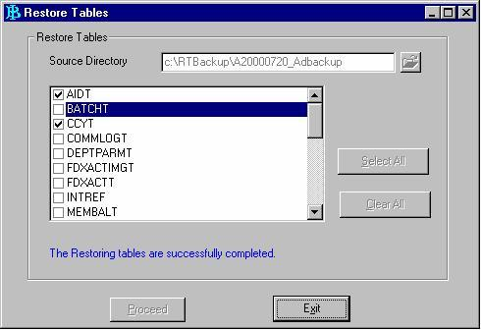
Image 3

- After restore is completed, click Exit to close this utility.
- Still on RT Super choose the menu Status – Reset system Status, and then change the system status into MidDay Shut-down – click Proceed.
- Sign off from RT Super application.
- Bank Official perform SSSS data restore from ST Super application
The procedures of SSSS data restore:
- Sign-on from ST Super application with user stadm1 or stadm2 and password default for restore SSSS
- From the menu Utility choose Restore Tables. Restore Tables will be displayed.

Image 4

- Click to choose back-up file directory. Directory will be displayed.

Image 5
- Choose Drive name from driver list box and choose Folder from the list on folder list box to show the location of Back-up File.
- Choose the tables to be restored:
Click Select All to choose all tables that will be restored, except for these following tables:
- DEPTPARMT
- UPLISSUERT
- PRTDEV
- SYSPARMT
- WSPARMT
because a database re-setting is needed if the tables are restored.
- Click Proceed to start restore process.
- After restore process is completed, a message will be displayed
‘The Restoring Tables are successfully completed'.
Image 6

- When restore is completed, click Exit to close this utility.
- Still on ST Super choose the menu Status – Reset system Status, and then change the system status into MidDay Shut-down – click Proceed.
- Sign-off from ST Super application.
- Bank Official will activate “Guest Bank” application, as shown in the following image:

Image 7

Click Initialize to initialize Guest Bank Participant
Image 8

- Bank Official performs RT and ST operational activity:
- Activate RT Server
- Activate ST Server
- Perform System start-up and Department start-up from RT Client
- Perform System start-up and Department start-up from ST Client
- Log-on to RCC from RT Client
- Input RTGS transaction data or up-load transaction data from the bank, from RT Client
- Input SSSS transaction data or up-load transaction data from the bank, from ST Client
- When it is completed Log-off from RCC from RT Client
- Recovery Activity after Guest Bank operation (performed in Bank Indonesia) :
- If Guest Bank activity is performed until RCC Cut-off, perform these following procedures:
- Participants perform System shut-down without BATCH activity from RT Client application
The procedures:
- Sign-on from RT Client application, using manager-level user
- From the menu System choose System shut-down, and then choose End of day shut-down.
- Participants perform System shut-down activity without BATCH activity from ST Client application
The procedures:
- Sign-on from ST Client application, using manager-level user
- From the menu System choose System shut-down, and then choose End of day shut-down.
- And then maximize the active Guest Bank application
- From the Guest Bank application, click Print to print the duration of Guest Bank usage and a report will be printed, as shown in the following image:

Image 9

- And then participants can perform BATCH activity from RT Client application.
The procedures:
- From RT Client main menu choose Batch → Print End of day Reports.
- From the main menu choose Batch → Backup Daily Files.
- Choose Directory.
- Choose Drive and Folder, and then click <OK>.
- Click <Proceed>.
- From the main menu choose Batch → Reset system Files.
- Enter password.
- Click <Proceed>.

- And then Participants can perform BATCH activity from ST Client application.
The procedures:
- From ST Client main menu choose Batch → Print End of day Reports.
- Choose reports that are going to be printed:
  - Incoming Transaction Journal Batch Report
  - Outgoing Transaction Journal Batch Report
  - Due Date Reminder for SSSS Transaction
Report
  - Daily Total Report
- From the main menu choose Batch → Backup Daily Files.
- Choose Directory.
- Choose Drive and Folder, and then click <OK>.
- Click <Proceed>.
- From the main menu choose Batch → Reset system Files.
- Enter password.
- Click <Proceed>.
- After Participants complete BATCH process, click Delete data from “Guest Bank” application to delete all RTGS and SSSS transaction data.
The procedures:
- From the main menu click Delete data and a message will be displayed, as shown in the following image:
Image 10

- Click Yes to delete database
- When Delete database process is completed, a message will be displayed as shown in the following image:

Image 11
- Click Ok, and then Exit from Guest Bank application
b. When Guest Bank activity is not done until RCC Cut-off, follow these procedures:

- Participants perform System shut-down activity without BATCH activity from RT Client application
The procedures:
- Sign-on from RT Client application, with manager-level user
- From the menu System choose System shut-down, and then choose MidDay Shut-down.
- Participants perform System shut-down activity without BATCH activity from ST Client application
The procedures:
- Sign-on from ST Client application, with manager-level user
- From the menu System choose System shut-down, and then MidDay Shut-down.
- And then maximize active Guest Bank application
- From Guest Bank application, click Print to print the duration of Guest Bank usage and a report will be printed, as shown in the following image:
Image 12

- And then participants can perform Adhoc Back-up activity from RT Super application.
The procedures:
- From RT Super main menu choose Utility → Adhoc Backup.
- Choose Directory.
- Choose Drive and Folder, and then click <OK>.
- Click <Proceed>.
- And then Participants can perform BATCH activity from ST Client application.
The procedures:
- From ST Super main menu choose Utility → Adhoc Backup.
- Choose Directory.
- Choose Drive and Folder, and then click <OK>.
- Click <Proceed>.
- After participants complete BATCH process, click Delete data from “Guest Bank” application to delete all RTGS and SSSS transaction data.
The procedures:
- From the main menu click Delete data and a message will be displayed as shown in the following image:

Image 13
- Click Yes to delete database
- After Delete database is completed, a message will be displayed as shown in the following image:
Image 14

- Click Ok, and then Exit from Guest Bank application

- Next the bank restores data on the Server on the location of each bank.
The procedures:
- RTGS data Restore is performed from the menu RT Super – Utility – Restore Tables.
- SSSS data Restore is performed from the menu RT Super – Utility – Restore Tables.
- Activate RT Server
- Activate ST Server
- Perform System start-up, Department start-up from RT Client
- Perform System start-up, Department start-up from ST Client
- Log-on to RCC from RT Client
- Perform RTGS and SSSS operational activities as usual, until end-of-day process.

*** Finished ***

- Procedures of the usage of Guest Bank facility on midday (RT/ST Server is crashed)
- Preparation of Participants (done in Participants’ office) :
- Write down the last BOR number based on accepted print-out on RTGS application.
- Write down the last MOR number based on accepted print-out on SSSS application.
- Carry the result of RTGS end-of-day data back-up (T-1) in two storing media such as CD or flash disk.
RTGS end-of-day Back-up is performed from RT Client menu Batch → Backup Daily Files.
The name of back-up file is for example: ddmmyy_back-up (141207_backup)
- Carry the result of SSSS end-of-day data back-up (T-1) in two storing media such as CD or flash disk.
SSSS end-of-day Back-up is performed from RT Client menu Batch → Backup Daily Files.
The name of back-up file is for example: ddmmyy_back-up (ST_141207_BEIIIDJA)
- Carry transaction data that will be kept in financial entry or RTGS transaction data from internal bank system (text file) that will be up-loaded to RTGS system.
- Carry transaction data that will be kept in financial entry or SSSS transaction data from internal bank system (text file) that will be up-loaded to SSSS system.
- Guest Bank Activities (performed in Bank Indonesia) :
- Bank Official will restore RTGS data from RT Super application
The procedures of RTGS data restore:
- Sign-on from RT Super application with user rtadm1 or rtadm2 and password default to restore RTGS
- From the Utility choose Restore Tables. Restore Tables will be displayed.

Image 1

- Click to choose back-up file directory. Directory will be displayed.

Image 2
- Choose Drive name from the list on driver list box and choose Folder from the list on folder list box to show the location of Back-up File.
- Choose tables to be restored:
Click Select All to choose all tables that are going to be restores, except for these following tables:
- DEPTPARMT
- PRTDEV
- SYSPARMT
- WSPARMT
because a database re-setting is needed if those tables are restored.
- Click Proceed to start restore process.
- After restore process is completed, a message will be displayed
‘The Restoring Tables are successfully completed'.

Image 3

- After restore is completed, click Exit to close this utility.
- Still on RT Super application, choose the menu Utility – Reset BOR Number,
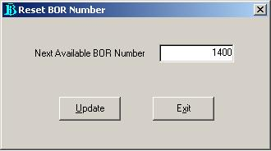
Image 4

Perform a reset on BOR number, add 1000 to the last BOR.
For example:
Last BOR : 400
Reset BOR Number into : 400 + 1000 = 1400
click Update.

- Click Exit to close this utility and sign-off
from RT Super application.
- Bank Official will restore SSSS data from ST Super application
The procedures of SSSS data restore:
- Sign-on from ST Super application with user stadm1 or stadm2 and password default to restore SSSS
- From the menu Utility choose Restore Tables. Restore Tables will be displayed.

Image 5

- Click to choose back-up file directory. Directory will be displayed.
Image 6

- Choose Drive name from the list on driver list box and choose Folder from the list on folder list box to show the location of Back-up File.
- Choose tables to be restored:
Click Select All to choose all the tables that will be restored, except for these following tables:
- DEPTPARMT
- UPLISSUERT
- PRTDEV
- SYSPARMT
- WSPARMT
because a database re-setting will be needed if those tables are restored..
- Click Proceed to start restore process.
- When the restore process is completed, a message will be displayed
‘The Restoring Tables are successfully completed'.
Image 7

- After restore is completed, click Exit to close this utility.
- Still on ST Super application, choose the menu Utility – Reset MOR Number.
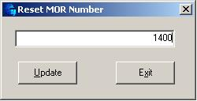
Image 8

Perform a reset on MOR number, add 1000 to the last MOR.
For example :
Last MOR : 400
Reset MOR Number into : 400 + 1000 = 1400
click Update.

- Click Exit to close this utility and sign-off from ST Super application.
- Bank Official will perform Batch Processing
The procedures:
  - Activate RT Server application
  - Activate ST Server application
  - From RT Client application choose Batch menu and then perform Reset system files
  - From ST Client application choose Batch menu and then perform Reset system files process
- Bank Official activates “Guest Bank” application, as shown in the following image :
Image 9

Click Initialize to initialize Guest Bank Participant
Image 10

- Bank Official RT and ST operational activity:
- Activate RT Server
- Activate ST Server
- Perform System start-up and Department start-up from RT Client
- Perform System start-up and Department start-up from ST Client
- Log-on to RCC from RT Client
- Input RTGS transaction data or up-load transaction data from the bank, from RT Client
- Input SSSS transaction data or up-load transaction data from the bank, from ST Client
- After it is completed, Log-off from RCC from RT Client
- Recovery Activity after Guest Bank operation (performed in Bank Indonesia) :
- If Guest Bank is performed until RCC Cut-off, follow the following procedures:

- Participants perform System shut-down activity without BATCH activity from RT Client application
The procedures:
- Sign-on from RT Client application, using manager-level user
- From the System menu choose System shut-down, and then choose End of day shut-down.
- Participants perform System shut-down activity without BATCH activity from ST Client application
The procedures:
- Sign-on from ST Client application, using manager-level user
- From the System menu choose System shut-down, and then choose End of day shut-down.
- And then maximize active Guest Bank application
- From Guest Bank application, click Print to print the duration of Guest Bank usage and a report will be printed, as shown in the following image:

Image 11

- After that, Participants can perform BATCH activity from RT Client application
The procedures:
- From RT Client main menu choose Batch → Print End of day Reports.
- From the main menu choose Batch → Backup Daily Files.
- Choose Directory.
- Choose Drive and Folder, and then Click <OK>.
- Click <Proceed>.
- From the main menu choose Batch → Reset system files.
- Enter password.
- Click <Proceed>.
- And then participants can perform BATCH activity from ST application.
The procedures:
- From ST Client main menu choose Batch → Print End of day Reports.
- Choose reports that will be printed:
        - Incoming Transaction Journal Batch Report
        - Outgoing Transaction Journal Batch Report
        - Due Date Reminder for SSSS Transaction Report
        - Daily Total Report
- From the main menu choose Batch → Backup Daily Files.
- Choose Directory.
- Choose Drive and Folder, and then Click <OK>.
- Click <Proceed>.
- From the main menu choose Batch → Reset system Files.
- Enter password.
- Click <Proceed>.
- When participants complete BATCH process, click Delete data from “Guest Bank” application to delete all RTGS and SSSS transaction data.
The procedures:
- From the main menu click Delete data and a message will be displayed as shown in the following image:

Image 12

- Click Yes to delete database
- After Delete database process is completed, a message will be displayed as shown in the following image:

Image 13

- Click Ok, and then Exit from Guest Bank application
  - If Guest Bank activity is not done until RCC Cut-off, follow the following procedures:
- Participants perform System shut-down activity without BATCH activity from RT Client application
The procedures:
- Sign-on from RT Client application, using manager-level user
- From System menu choose System shut-down, and then choose MidDay Shut-down.
- Participants perform System shut-down activity without BATCH activity from ST Client application
The procedures:
- Sign-on from ST Client application, using manager-level user
- From System menu choose System shut-down, and then choose MidDay Shut-down.
- And then maximize active Guest Bank application
- From Guest Bank application, click Print to print the duration of Guest Bank usage and a report will be printed, as shown in the following image:

Image 14

- And then participants can perform Adhoc Back-up activity from RT Super application.
The procedures:
- From RT Super main menu choose Utility → Adhoc Backup.
- Choose Directory.
- Choose Drive and Folder, and then Click <OK>.
- Click <Proceed>.

- After that, participants can perform BATCH activity from ST Client Application.
The procedures:
- From ST Super main menu choose Utility → Adhoc Backup.
- Choose Directory.
- Choose Drive and Folder, and then Click <OK>.
- Click <Proceed>.
- After participants complete BATCH process, click Delete data from “Guest Bank” application to delete all RTGS and SSSS transaction data.
The procedures:
- From the main menu click Delete data and a message will be displayed as shown in the following image:

Image 15

- Click Yes to delete database
- When Delete database process is completed a message will be displayed as shown in the following image:

Image 16

- Click Ok, and then Exit from Guest Bank application
  - Next, the Bank Restores Data on the Server in the location of each bank.
The procedures:
- RTGS Data Restore is performed from the menu RT Super – Utility – Restore Tables.
- SSSS Data Restore is performed from the menu ST Super – Utility – Restore Tables.
- Activate RT Server
- Activate ST Server
- Perform System start-up, Department start-up from RT Client
- Perform System start-up, Department start-up from ST Client
- Log-on to RCC from RT Client
- Perform RTGS and SSSS operational activities as usual, until end-of-day transaction process.

*** Finished ***

